**Little Einsteins CC Ltd**

**Nursery Brochure**

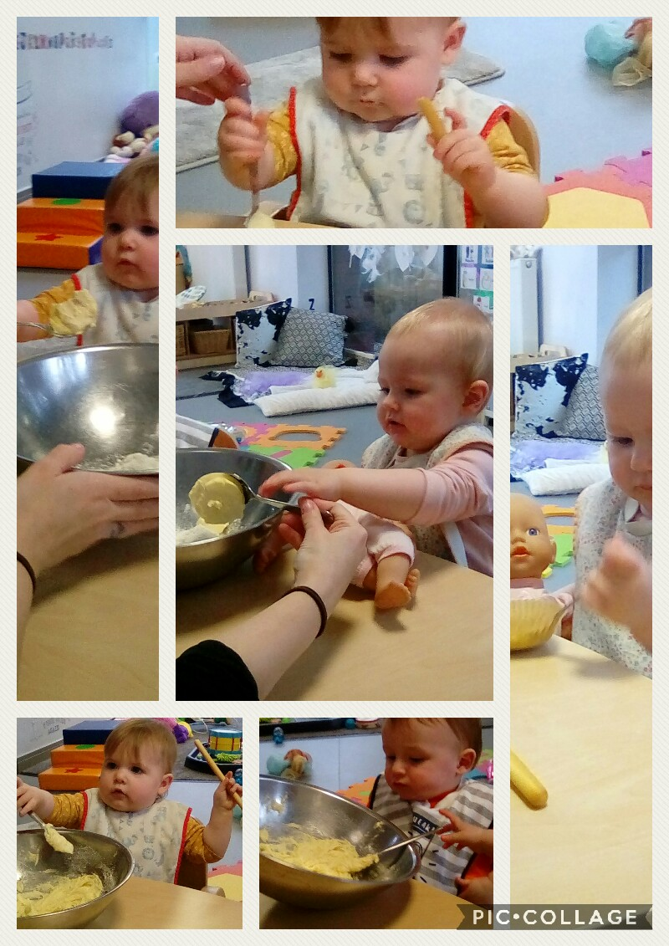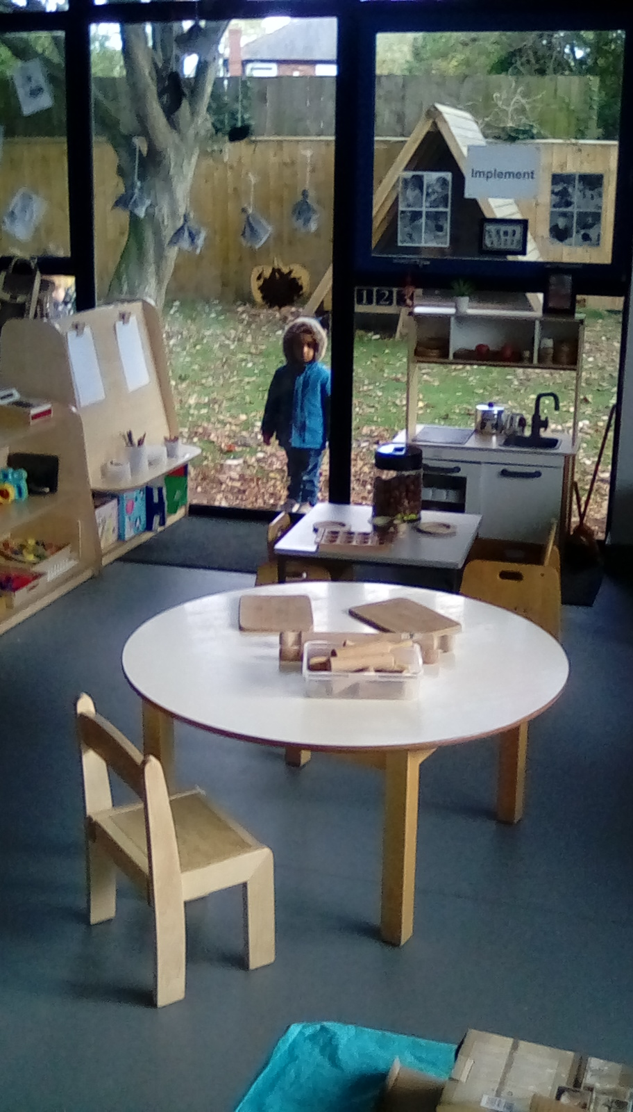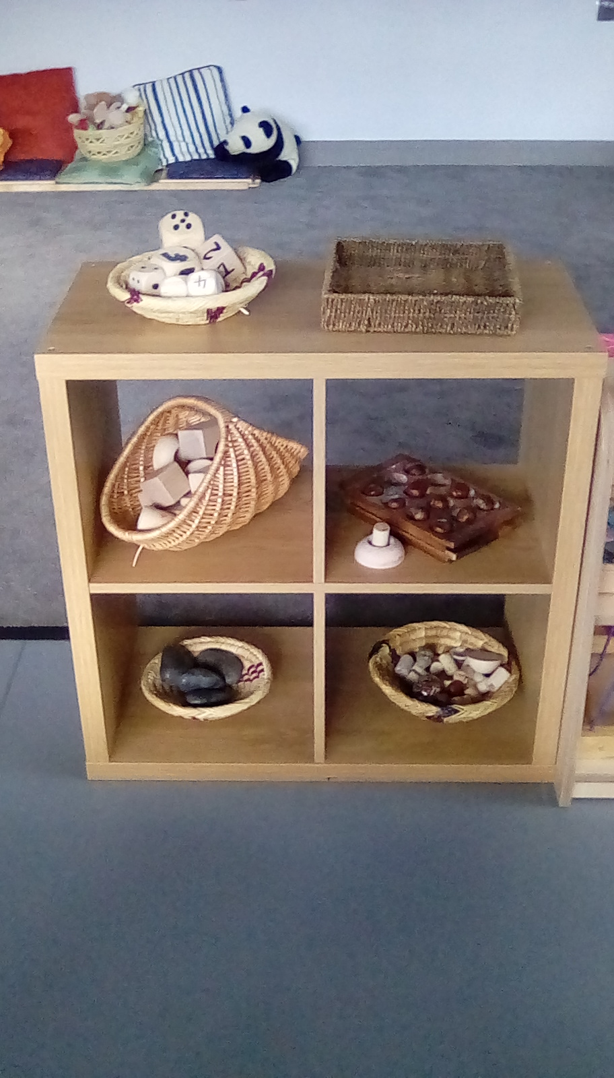

4a Newlands Science Park, University of Hull Campus, Hull HU6 7TQ

Fully air conditioned

117 Cranbrook Avenue, Hull HU6 7SS

St Aidans Church, Lorenzo Way Hull (Out of School Club)

Tel/Fax 01482 803934/805816

Director Wendy Oliver [w.oliverbirch@leccl.karoo.co.uk](mailto:woliverbirch@leccl.karoo.c.k)



Mission &Vision &Values

**Mission:** To enhance the lives of children and families by creating a nursery that feels like home in an extended and supportive family environment & to offer exeptional customer care

**Vision:** At Little Einsteins we have a clear picture of what we want to achieve, and we do this by:

* Placing the child at the heart of everything we do
* Working together in an environment where everyone is a partner in learning, providing a safe, happy, caring and stimulating environment
* Ensuring children are given the opportunities to reach their full potential
* Making all parents and carers welcome with an open door policy
* Caring for children as if they were our own
* Being fully inclusive

**Values:**

Your Smile is our Smile



**Little Einsteins CC Ltd**

We would like to welcome you to Little Einsteins Childcare Centre Ltd. This brochure is designed to provide you with information and policies that promote our good practice, facilities and the care we provide in a safe and stimulating environment.

Little Einsteins Childcare Centre is located on the University of Hull Campus, it first opened its doors in 1973 and since has built up an excellent reputation and is amongst the leading providers of childcare provision. We have a dedicated and professional team who are highly qualified and work within National Frameworks to ensure high quality child care is delivered.

In 2017, we opened our second setting, adjacent to our existing nursery, this expansion was in response to the new 30 hour funding formula and to ensure everyone has access to childcare.

In September 2008, the Early Years Foundation Stage (EYFS) was introduced. The framework sets the standards for learning, development and care for children Birth to Five. In September 2012 the revised EYFS was implemented, a copy of the revision can be obtained from the nursery, please ask for an electronic copy to be sent to you.

*“Play is children’s way of learning”*

*“In their play, babies, toddlers and young children try out their recent learning, skills and competences when they play, they show their highest level of learning”*

The nursery is open from 7.30am to 6.00pm Monday to Friday. We are closed all bank holidays, Christmas Eve and for a week at Christmas.

We offer either full-days 7:30 am-6.00 pm or sessional care.

Morning Session 7:30am –12.30pm

Afternoon Sessions 1:00pm –6.00 pm

A minimum of 2 sessions per week is advisable. The nursery staff must be informed in writing or by telephone if anyone other than a parent is collecting a child from the nursery, and they will need to know your personal password. We will also ask for the persons collecting Name, address and date of birth for extra security. They will need to bring ID with them.

The nursery welcomes all childcare vouchers and offers free sessions for children aged 2, 3 & 4 years. Little Einsteins offers an invaluable service to the staff and students of the University as well as being open to the general public.

Any changes to your sessions or cancellation of your placement must be given by email or letter ([w.oliverbirch@leccl.karoo.](mailto:w.oliverbirch@leccl.karoo.)co.uk) or to the above address. Four weeks’ notice is required to cancel or change your booking.

We hope the following information will help you in your decision to choose the best possible childcare, please do not hesitate to visit the setting at your convenience to see our facilities and meet the staff. Parents are welcome to spend time with us and participate in the nursery day

**Settling your child into the nursery** At Little Einsteins we want to ensure that when you leave your child in our care you feel confident to do so and that the experience is a good one for you and your child. Once you have enrolled your child and confirmed your place by paying the deposit we will arrange for you to make settling in visits. These are designed for you and your child to be able to start forming a relationship with your key person, the staff and other children in the room.

Our usual recommendation is to start the visits one week before the expected start date; visits are usually for 1 hour the first visit and a half day session the second visit. If you feel your child may take longer to settle, then you may start visits earlier.

On the first visit, we ask you to stay with your child and play, the second visit you may leave your child for 15 minutes. On subsequent visits you may extend the time you leave your child until the full hour is achieved and you feel happy to leave them in our care.

If you feel your child is experiencing any difficulties being left, the staff will only be too happy to assist you, please discuss your concerns with us.

Do not hesitate to ask questions and discuss yours and your childs needs with the staff.

Once your child has started, you may telephone at any time to see how they are getting on.

**Our Key Person System** A member of staff will be allocated to your child as a “key person‟. She will be the named carer throughout the nursery day and is the first point of contact for parents. She will record information regarding your child’s home routine, as well as specific information such as medication instructions. Changes in routine at home can affect your child‟s well being. It is important that the key person and playroom staff know about these changes so that the best possible care can be provided. The key person will note a record of achievements, and may ask the parents for input. This record or profile is available on request. At Little Einsteins, we use the Key person system because we feel that this is the best way to help your child feel safe and secure in the nursery and to give you reassurance.

**Our Key Person System Provides** Assistance with the settling in process

Close monitoring of your child’s progress in all areas of development.

A Personal contact for parents / guardians, however, all our staff are available to talk to parents.

Knowledge of your child’s needs when planning activities and curriculum.

**A Child’s Key Person** Will give information to parents regarding the routines, daily timetables and activities in the room.

* They will help both parent and child during the settling in period, reassuring and helping them.
* They will help the child become comfortable with the routines of a session, making sure they become familiar with the room and feel comfortable.
* Build up a reassuring relationship with your child.
* Will try to be aware of any home circumstances that may affect the child’s behaviour.
* Will carry out observations of the children in their group and devise plans for activities taking into account each child’s own needs.
* Will be available to parents to give feedback on what your child has been doing during their time at nursery / pre-school.
* Will liaise, in conjunction with parents, management and outside agencies, especially if a child has a special need.
* Take care of your child’s personal needs i.e. nappy changing, whenever possible.

**Parents as Partners** At Little Einsteins we acknowledge the importance of building good relationships with our parents. It is important that there is good liaison between parents/carers and the staff. With this in mind we endeavour to do this by:-

* Allowing parental visits to our settings, without prior appointment
* Providing an open door policy at all times
* Holding parents' evenings
* Having flexible admission and settling in procedures
* On our app ‘Famly’ we provide information about topics, activities and events being held.
* Provide daily feedback in respect of your child’s well-being and development.
* Provide information on child care and rearing topics, training opportunities, and other interesting topics.

**Arrival and Collection of Children**

**When you bring your child to the nursery**

* Please tell a member of staff any relevant information that you feel we should know about your child.
* Record any medication or other requirements your child may need
* Tell us if anyone other than yourself/partner is collecting your child and at what time and confirm the password to be used.
* Please remember to check your post box, situated in the your child’s room
* When entering and leaving the nursery please ensure that the front door is closed securely after you. It only takes a minute for a child to slip out or for a stranger to get in. Please do not allow anyone else into the building.

**When picking up your child from nursery** Please discuss your child’s day with his/her Key person, if your child’s key person is not available, she will pass all information on to her co-workers. If your child has had an accident during the day, it will be recorded on an accident form and slip will have been completed. Please ensure that you read the accident form and sign it.

**Payment of Fees** For a full breakdown of our fees and discounts, refer to the separate Fees Structure. Fees are reviewed annually in April

A Deposit is payable upon acceptance. Places cannot be confirmed or reserved until these fees are received.

All fees are due in advance and on the 1st of each month by standing order

Extra sessions must be paid on the day.

For funded parents for example Student finance, you are expected to have your finance in place from your start date. If you do not receive your funding in time for your start date, you will be expected to pay your fees personally and reclaim when received

**Vouchers – Grants, Tax Credits, Nursery Grant – 2,3 & 4 years**

Eligible 3-4 year olds will receive the nursery grants 3 times per year. These grants are paid direct to the nursery by the government and your nursery education discount will be worked out and deducted from your monthly fees. You will be notified on each invoice how many hours funding you have received.

The grant is payable in the term following their 2nd or 3rd birthday. Grant amounts are paid pro rata according to the number of sessions you register for.

**Nursery Vouchers** Little Einsteins accept nursery vouchers from your employer, the voucher system allows you to make savings on Tax and National Insurance. Vouchers can be paid either electronically or redeemed by the nursery. You then make up the difference between the vouchers and the nursery fees. Further information can be obtained from the management team.

Tax free childcare

Tax free childcare offers parents with children under 12 upto £2000 per child, per year, towards their childcare costs (or under 17 and upto £4000 for disabled children). Eligible parents entering the scheme will open an online childcare account that they can use to pay for their childcare. To find out more information go to:-https://www.childcarechoices.gov.uk/

**Working Tax Credits** Help is available to pay towards childcare through the childcare element of Working Tax Credit. It can provide substantial support with childcare costs and many families find that they are eligible. You or your partner needs to work a minimum of 16 hours per week to qualify. Information leaflets are available at the nursery.

If you have any questions you can contact the government: Working Tax Credit/Child Tax Credit helpline which is open 8:00am – 8:00pm seven days per week.

**Telephone number 0845 300 3909**

Alternatively you may log on at: h**ttps://www.taxcredits.inlandrevenue.gov.uk/HomeIR.aspx**

**Little Einsteins CC Ltd – Privacy Notice**

To meet the requirements of the Data Protection Act 1998, early year’s settings are required to issue a Privacy Notice to children and young people and/or parents and guardians summarising the information held on record about children and young people, why it is held, and the third parties to whom it may be passed.

This privacy notice provides information about the collection and processing of children’s or young people’s personal and performance information by the early year’s provider

**What data do we collect?**

**Children:**

* Full name;
* Date of birth;
* The name and address of every parent and carer who is known to the provider;
* which of these parents or carers the child normally lives with;
* Emergency contact details of the parents and carers.
* Providers must record and submit the following information to their local authority about individual children receiving the free entitlement to early years provision as part of the Early Years Census
* Gender;
* Ethnicity;* optional
* Special educational needs status;
* The number of funded hours taken up during the census week;
* Total number of hours (funded and unfunded) taken up at the setting during the census week.

**Parents:**

Names, addresses, Date of birth and national insurance numbers

**Staff:**

Staff information; such as bank details, date of birth national insurance number and qualifications

**The collection of information**

Little Einsteins collects information about children and young people and their parents or legal guardians when children and young people enrol at the setting. Little Einsteins also collects information at other key times throughout the year and may receive information from other settings when children or young people transfer.

Little Einsteins processes the information it collects to administer the education we provide to children and young people for example:

* The individual educational plans
* The monitoring and assessing of children’s educational progress
* The welfare, care and health support and services
* The support and guidance for children and young people, their parents and legal guardians
* The organisation of trips, walks around the campus and educational visits
* The planning and management of the nursery
* full name;
* date of birth;
* the name and address of every parent and carer who is known to the provider;
* which of these parents or carers the child normally lives with;
* emergency contact details of the parents and carers.
* Providers must record and submit the following information to their local authority about individual children receiving the free entitlement to early years provision as part of the Early Years Census:

**Where do we store the data**

All information collected is stored in the following ways:

On emails, documents, databases, backups, filing units

**How do we protect and document the data we have?**

All data is password protected, limited access, lockable filing cabinets

**How long do we keep the data for?**

Children’s and parents records are kept for 3 years after a child has left the setting, the records will then be shredded

Staff records are kept for 5 years after the staff member has left the setting, the records will then be shredded.

Famly journal is deleted a day after the child leaves the setting

**Do we have a function/Reason for every piece of data we collect**

All information collected is needed to ensure the safeguarding and welfare of all children and staff, if we find the information is not relevant then we will stop asking for that information. You can ask for your information to be returned to you and that we do not store your information anymore at any time.

**Ladybirds, Ducklings & and Honeybees (Our under 2’s rooms)**

Lady Birds Room LE1 (6weeks – 1 year) 6:children : 2 staff

Bumble Bees LE1 (1 year – 2 years) 9 children : 3 staff

Ducklings Room LE2 (6 weeks – 1 year) 9 children : 3 staff

Honeybees Room LE2 (1 year – 2 years) 12: children : 4 staff

The staff are dedicated to providing much love and stimulation for the babies in their care.

The following points will be incorporated into their daily routine for your information.

*Feedback sheets

*Key Person

*Frequent nappy changes

* Water and milk will be offered at regular intervals

*A baby will never be left unsupervised

*Child Care plan is completed and followed for each individual child

* A high standard of hygiene is maintained at all times

* If a baby appears unwell or has a high temperature the staff member will inform the nursery manager or her assistant immediately who will then contact the parent/guardian.

*A wide variety of appropriate activities are on offer following the child’s interests

*We encourage each child’s individual development by providing stimulating toys, equipment and activities and enjoy regular walks in the summer months.

*We recommend you bring your child for 2 visits prior to leaving your child for the first time.

The staff plan activities around their individual interests and levels of development following in conjunction with the Early years foundation stage. Each baby has a peg and a basket for their belongings. Please provide a spare set of clothing (labelled) and disposable nappies, any creams necessary. Please label all your belongings. When they are nearly two years old the babies have a transition period into the monkey room. This will be discussed with you prior to any change in their nursery routine.

**Squirrels,Monkeys,Dolphins & Butterflies**

Squirrels LE2 (2–3 years) 16 children : 4 staff

Chipmunks LE2 (2.5 – 3.5 years) 16 children: 4 staff

Monkeys LE1 (2-3 years) 16 children : 4 Staff

Dolphins LE1 (3-5 years) 24 Children : 3 Staff

Butterflies LE2 (3–5 years) 24 Children : 3 Staff

The staff in the above rooms are dedicated to providing a caring, stimulating and safe environment in which the children can learn and develop. The staff plan their activities around the individual needs of the children following the Early Years Foundation Stage. The staff in these rooms observe and assess each child’s development and record their progress in their Foundation Stage profile. These are readily available in the parent’s information boxes. Parent information boxes are located in each room, we use them to pass on information to yourselves. The six areas of learning are promoted inside and outside through routines, free play and adult led activities.

The children enjoy having lots of fun which includes lots of creative and physical activities. We encourage the children to be independent thinkers by offering a range of resources and allowing them to use their own thoughts and ideas to create their own pieces of work and play. Each child has their own coat peg with a recognisable picture to help them become familiar with their own name and surroundings. As part of their daily routine the children all sit together for group time and take part in listening to stories and music, singing, action rhymes, playing with musical instruments and talking about shapes and colours.

The staff follow the ‘Sticky Kids’ music and movement resource (www.stickykids.co.uk) Sticky Kids is a comprehensive learning resource for the early years practitioner. The music and movement songs will help achieve the goals set out by the early years curriculum requirements, not only in physical development but also in other learning fields.

The children and staff enjoy going for walks around the campus and looking at the local environment that surrounds them. We have a large outdoor provision which is used continually so the children have the option of been in or out. The six areas of learning are included as part of our continuous outdoor provision.

At meal and snack times the children are encouraged to wash their hands independently. The children help prepare for lunch by setting the tables with cutlery and place mats. Each child has their own water bottle to drink freely throughout the day. After lunch part of the Monkey room is used for those children that require an afternoon nap.

A change of clothing is required and nappies/pull ups if necessary. When your child is ready to be toilet trained, please speak to your child’s key person and we will be happy to support you with this. Please provide additional clothing when your child is toilet training.

“Children who begin their education in a learning environment that is vibrant, purposeful, challenging and supporting stand the best chance of developing into confident and successful learners”. Effective learning environments are created over time as the result of practitioners and parents working together, thinking and talking about children’s learning and planning how to promote it”. (EYFS 2008 & 20120)

At the nursery we follow the guidelines laid down by:

1. The Dept of Education and Employment (DFEE) for the Government Funding of 3+4 years old.
2. The QCA (Qualification and Curriculum Authority)Early Learning Goals for the Foundation Stage, incorporating the following areas,

*Personal, Social and Emotional development

* Communication, language, and Literacy development

*Problem Solving, reasoning and numeracy

*Knowledge and understanding of the world around them

*Physical Development

*Creative Development

**Food and Drink** A variety of healthy snacks, fruit, milk and water is available throughout the nursery sessions to drink and eat freely when the children are hungry or thirsty. The children are given the option of warm buttered toast at 9.30am if they would like a piece . A home cooked lunch is provided at approximately 12.00noon for children who are booked in for the lunchtime session. Please inform us before 11.30am if you require a lunch. The nursery has a cook who provides a healthy balanced lunch. The menus are on a four weekly rolling rota which are changed seasonally. The menus are displayed around the nursery, if you require a copy just let us know and we will be happy to provide you with this. A high tea is provided at 4.00pm, fresh fruit is available if you would prefer for your child to have tea at home.

Special dietary requirements are provided for. If you would like to discuss this further please speak to child’s key person.

**Nursery Policies** Policy statements on the following are displayed in the nursery reception area, detailed policies are available on request from the nursery manager. Please feel free to read through these policies.

*Behaviour Management

*Early Years Foundation Stage

*Child Protection

*Equal Opportunities

*Health and Safety

*Special Needs

As a child care establishment with staff who are in direct contact with children and families, we are involved in their inter agency process which is fundamental to the protection of children from harm. The nursery must notify Ofsted about any allegations of serious harm or abuse against a child while in our care.

**Children’s Records** A record of your child’s development and progress will be kept at the nursery from the time they start with us, regardless of age. On leaving the nursery you will be given the profile of your child’s work which will provide useful information for your chosen primary school and be an invaluable memento for yourself of your child’s pre-school years. Please feel free to browse through your child’s portfolio and contribute by adding pieces of work, photos or achievements.

**Parent’s Evenings** We hold an open night twice a year when you are invited to come along and discuss your child’s progress with their key person.

**Student Placements** We have many students on placement with us throughout the year, all of whom are police checked prior to their inclusion on child care courses with various colleges. All students are never left unsupervised with any children.

**Complaints Procedure** We pride ourselves in working closely and in partnership with all of our parents. If you are not happy with any aspect of our care please feel free to discuss this with our staff or the nursery manager. If you do not feel that this is satisfactory, complaints can be made to ofsted –

Ofsted Early Years, National Business Unit, Royal Exchange Buildings, St Ann’s Square

Manchester, M27 LA

**Illness**

Children cannot be admitted to the nursery with a high temperature, sore throat, sickness and / or diarrhoea. Children with sickness and / or diarrhoea must be kept away from the nursery for 48 hours from the last period of illness. In case of infectious diseases please inform the manager immediately of the diagnosis. If the Nursery Manager considers a child is not well enough to attend nursery she may request that the child be taken home and may require a doctor’s note before the child is re-admitted. Children prescribed antibiotics cannot be admitted to the nursery until they have had 3 doses or if it is an antibiotic they have not had before , they cannot be admitted for the first 48 hours. Full Fees are charged for periods of illness.

The Nursery Manager has the right to refuse admission of a child who they feel is not well enough to stay at the nursery.

If your child becomes ill whilst attending the nursery, you or your nominated contact will be asked to collect them as soon as possible. You must not send your child to the nursery if they are ill.

The nursery will not accept liability for any missing or damaged children’s clothes, toys or possessions. The nursery will not accept liability for any vehicles, cycles, pushchairs or other personal items left or parked on the premises.

This agreement is subject to change in whole or part by the company with one month’s notice. The notice is deemed to have been given provided that the changes are displayed on the parents/carers notice board in the nursery entrance.

|  |  |  |
| --- | --- | --- |
|  |  |  |

